Projectile Motion
In the following problems, ignore air resistance unless it is explicitly included.

1. A tiger leaps horizontally from a 7.5-m-high rock with a speed of 3.0 m/s. How far from the base of the rock will she land?

3.7 m

2. A diver running 2.5 m/s dives out horizontally from the edge of a vertical cliff and 3.0 s later reaches the water below. How high was the cliff and how far from its base did the diver hit the water?

44.1 m high and 7.5 m far horizontally

3. A ball thrown horizontally at 12.2 m/s from the roof of a building lands 21.0 m from the base of the building. How high is the building?

14.5 m

4. A football is kicked at ground level with a speed of 18.0 m/s at an angle of 31.0° to the horizontal. How much later does it hit the ground?

1.90 s

5. A projectile is fired with an initial speed of 36.6 m/s at an angle of 42.2° above the horizontal on a long flat firing range. Determine (a) the maximum height reached by the projectile, (b) the total time in the air, (c) the total horizontal distance covered (that is, the range), and (d) the speed of the projectile 1.50 s after firing.
- 30.8m; b) 5.02 sec.; c) 136 m; d) 28.8 m/s
6. A shot-putter throws the “shot” (mass = 7.3 kg) with an initial speed of 14.4 m/s at a 34.0° angle to the horizontal. Calculate the horizontal distance traveled by the shot if it leaves the athlete’s hand at a height of 2.10m above the ground.

23.21 m

7. A baseball is hit with a speed of 27.0 m/s at an angle of 45.0°. It lands on the flat roof of a 13.0-m-tall nearby building. If the ball was hit when it was 1.0 m above the ground, what horizontal distance does it travel before it lands on the building?

59.18 m

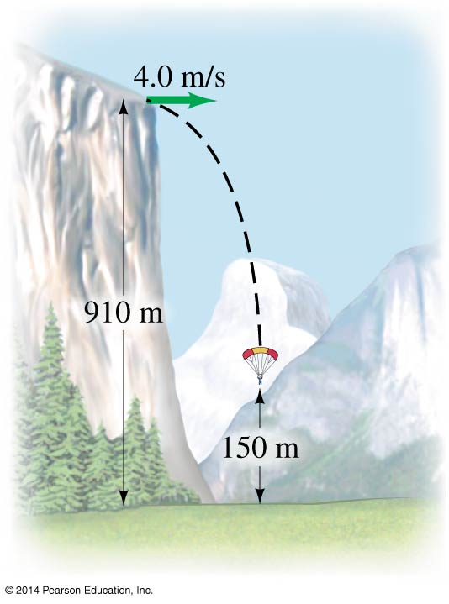
8. Extreme-sports enthusiasts have been known to jump off the top of El Capitan, a sheer granite cliff of height 910 m in Yosemite National Park. Assume a jumper runs horizontally off the top of El Capitan with speed 4.0 m/s and enjoys a free fall until she is 150 m above the valley floor, at which time she opens her parachute (see figure above). (a) How long is the jumper in free fall? Ignore air resistance. (b) It is important to be as far away from the cliff as possible before opening the parachute. How far from the cliff is this jumper when she opens her chute?
- 12.4 seconds
- 49.6 m

